**Problem Statement**

To create a function from past data points that can calculate the percentile if we add new data point on same function.

1. **Percentile for Grouped Data**

We have been calculating percentile on continuous data till now. But what about we calculate on grouped data.

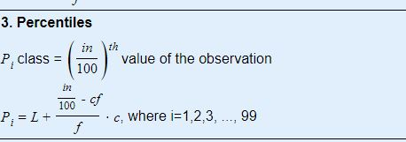

Fig: Calculation of Percentile for grouped data

**Demonstration**

|  |  |
| --- | --- |
| Group | Frequency |
| 2 - 4 | 3 |
| 4 - 6 | 4 |
| 6 - 8 | 2 |
| 8 - 10 | 1 |

**Solution:**

|  |  |  |
| --- | --- | --- |
| **Group** | **Frequency *f*** | ***cf*** |
| 2 - 4 | 3 | 3 |
| 4 - 6 | 4 | 7 |
| 6 - 8 | 2 | 9 |
| 8 - 10 | 1 | 10 |
| --- | --- | --- |
|  | n = 10 | -- |

Here, *n*=10

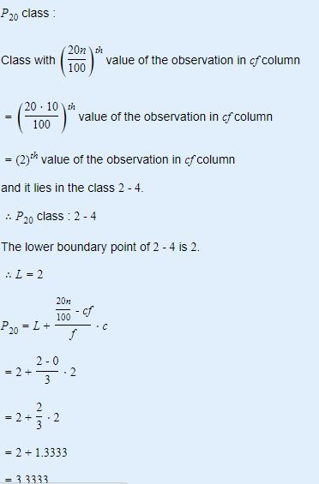

Advantages

* If new data is introduced, making group won’t distort the frequency of another group except the group it actually lies.

Disadvantages

* The same problem of calculation and memory arises: we need to make a new group, new frequency, new table, new percentile calculation if new data is introduced